ANUDIP FOUNDATION

**Project Title**

**“Student Management System”**

**By**

|  |  |
| --- | --- |
| **Name** | **Enrollment No** |
| **Samiksha Karanda**  **Sakshi Karande** | **AF0481922** |

**Under Guidance**

**Of**

**Rajshri Thete**

**ABSTRACT**

This project is a web-based **Student Management System** developed using the **Django web framework**. It aims to streamline and automate various administrative tasks involved in managing student data. The system allows administrators, staff, and students to interact through role-based dashboards.

**Key Features:**

* **User Authentication & Authorization** for Admin, Staff, and Students.
* **Admin Panel** for managing students, staff, courses, subjects, and sessions.
* **Staff Panel** to manage attendance, grades, and communication with students.
* **Student Panel** for viewing attendance, results, and notifications.
* **Database Integration** for storing user and academic data securely.
* **Responsive UI** using Bootstrap or similar frameworks.

#### ****Technology stack:****

* **Frontend:** HTML, CSS, JavaScript (with Bootstrap)
* **Backend:** Python (Django Framework)
* **Database:** SQLite (or other supported RDBMS)
* **Server:** Django development server or deployed on platforms like Heroku

The main objective of this project is to **automate** and **centralize** student-related activities such as enrollment, attendance, grading, and communication between students and staff. It significantly reduces manual effort, improves accuracy, and provides a user-friendly interface for managing data efficiently.

**ACKNOWLEDGEMENT**

The project **“Student Management System”** is the Project work carried out by

|  |  |
| --- | --- |
| **Name** | **Enrollment No** |
| 1.Samiksha Bharat Karande  2.Sakshi Goraksha Karande | AF0481922  AF0482710 |

Under the Guidance.

**Rajshri Thete**

We are thankful to my project guide for guiding me to complete the Project.

His suggestions and valuable information regarding the formation of the Project Report have provided me a lot of help in completing the Project and its related topics.

We are also thankful to my family member and friends who were always there to provide support and moral boost up.

|  |  |
| --- | --- |
| **TOPIC OF THE PROJECT** | ***Page No*** |
| 1. ***Title of the Project*** 2. ***Introduction/Objective***     1. ***Introduction***    2. ***Objective*** 3. ***System Analysis***     1. ***Problem Definition***    2. ***Preliminary Investigation***    3. ***Feasibility Study***    4. ***Project Planning***    5. ***Project Scheduling***    6. ***Software Requirement Specification***    7. ***Functional Requirements***    8. ***Software Engineering Paradigm*** 4. ***System Design***     1. ***Modularization Details***    2. ***Database Design***    3. ***Procedural Design***    4. ***User Interface Design***    5. ***Outputs of the Report***      1. ***Coding***     1. ***Complete Project Coding***    2. ***Error Handling*** | **1-1**  **2-3**  **2-2**  **3-3**  **4-26**  **4-4**  **4-6**  **6-11**  **11-12**  **12-13**  **14-17**  **18-18**  **19-19**      **27-67**  **27-27**  **28-31**  **32-38**  **39-40**  **41-41**    **42-85**  **42-79**  **80-80** |
| ***5.3. Code Improvement***  ***5.4. Parameters Passing***  ***5.5. Validation Check***   1. ***Testing***     1. ***Testing Strategies***    2. ***Conduction Test Cases*** 2. ***System Security Measure***     1. ***Security Strategies***    2. ***Interface Security***    3. ***Database Security***      1. ***Future Application of the Project***      1. ***Bibliography*** | **81-82**  **83-83**  **84-85**  **86-93**  **86-88**  **89-93**  **94-96**  **94-95**  **95-96**  **96-96** |

**TITLE OF THE PROJECT**

“STUDENT MANAGEMENT SYSTEM USING DJANGO”

**INTRODUCION AND OBJECTIVE OF THE PROJECT**

Managing educational institutions involves handling large volumes of student-related data such as admissions, attendance, grades, schedules, and communication. Traditionally, these tasks are managed manually, which can lead to inefficiencies, errors, and a lack of coordination. With the increasing digitization of services, there is a pressing need for an intelligent system that can centralize and streamline student management activities.

This project, Student Management System Using Django, is a web-based solution developed using the Django framework, one of the most robust and scalable Python web development tools. The system provides distinct interfaces and functionalities tailored to three main user roles: Admin, Staff, and Student. Each user type is given access to features relevant to their roles, promoting efficiency, transparency, and ease of use.

The system can be used by schools, colleges, and universities to manage academic records, attendance, communication, and performance tracking in a centralized digital format.

he Student Management System using Django is a web-based application designed to streamline and automate academic and administrative tasks in educational institutions. Built with the Django framework, the system provides role-based access for Admin, Staff, and Students, allowing each to manage their responsibilities efficiently. It simplifies tasks like attendance, grading, student data management, and communication, reducing manual effort and improving data accuracy.

**OBJECTIVES:**

The main objective of this project is to **automate** and **centralize** student-related activities such as enrollment, attendance, grading, and communication between students and staff. It significantly reduces manual effort, improves accuracy, and provides a user-friendly interface for managing data efficiently.

The primary objective of this project is to **develop an efficient and scalable student management platform** that:

1. **Automates Core Academic Operation**

Eliminates the need for paper-based record keeping by automating tasks such as managing student profiles, staff details, course allocations, attendance tracking, and grading.

1. **Provides Role-Based Access Control**

Ensures that users (Admin, Staff, Students) have personalized dashboards and permissions based on their responsibilities and needs.

1. **Improves Data Accuracy and Accessibility**

Allows real-time access to academic data, improving accuracy in grading and attendance, and making records easily retrievable.

1. **Enhances Communication**

Enables efficient communication between staff and students via built-in notification and messaging features.

1. **Scales with Institutional Needs**

Built using Django, the system is modular and scalable, allowing for future enhancements such as integration with fee management, timetable scheduling, or online learning tools.

**PROBLEM DEFINITION**

**SYSTEM ANALYSIS**

Managing student data manually or through basic tools like spreadsheets is inefficient, error-prone, and time-consuming—especially in institutions with a large number of students. Tasks such as maintaining attendance, recording grades, managing courses, and communicating with students become increasingly complex and difficult to track. Furthermore, the lack of centralized access to real-time academic data creates delays in decision-making and reduces transparency between students, staff, and administrators.

There is a need for a **centralized, automated, and role-based web application** that simplifies student information management, improves data accuracy, enhances communication, and enables secure, real-time access to academic records for all stakeholders

**PRELIMINARY INVESTIGATION:**

# Purpose

# –The purpose of the primary investigation is to understand the current challenges in student information management within educational institutions and determine the need for a software-based solution. It helps define the scope, feasibility, and direction of the proposed system.

**Key Features of the Proposed System**

**🔹 Admin Panel**

* Add/update/delete students, staff, courses, and subjects
* Assign staff to courses and subjects
* Create and manage academic sessions
* View and generate attendance and performance reports
* Send notifications to staff and students

**🔹 Staff Panel**

* Take student attendance and mark absences
* Add and update student grades/results
* View student profiles and subject lists
* Communicate with students via notifications

**🔹 Student Panel**

* View attendance records
* Access exam results and grades
* Receive academic notifications and announcements
* Update personal information

# Benefits-

**1. Centralized Data Management**

All student, staff, course, attendance, and grading information is stored in one place, reducing duplication and improving data consistency.

**2. Role-Based Access**

Customized dashboards and permissions for Admin, Staff, and Students ensure users can only access the features relevant to their role, enhancing security and usability.

**3. Improved Efficiency**

Automating tasks like attendance, result entry, and student management significantly reduces manual work and administrative overhead.

**4. Real-Time Access**

Users can access academic records, notifications, and updates instantly from anywhere through the web interface, improving communication and responsiveness.

**5. Data Accuracy and Integrity**

Minimizes human errors in records by using validation, predefined structures, and automated processes, ensuring more accurate and reliable data.

**6. Better Communication**

The built-in notification system allows Admin and Staff to send timely messages to students, improving engagement and transparency.

**7. Scalable and Maintainable**

Built with Django, the system can be easily updated or expanded with new features (e.g., online exams, fee management) as institutional needs grow.

**8. Secure Access**

Authentication mechanisms and session management ensure only authorized users can access sensitive academic and personal data.

**Proposed System –**

The proposed system is a **web-based Student Management System** developed using the **Django framework**, designed to automate and streamline all major student-related administrative functions in educational institutions.

It provides **role-based access control** for three primary user types: **Admin, Staff**, and **Students**, offering each a dedicated dashboard to perform their tasks efficiently.

**Technical Specifications :**

* **Frontend:** HTML, CSS, Bootstrap (for responsive UI)
* **Backend:** Django (Python framework)
* **Database:** MySQL
* **Other Tools:** JavaScript, jQuery for interactivity

**REQUIREMENT SPECIFICATIONS**

The requirements that are to be satisfied from the proposed system are:

* **To ensure Reliability:** System performs its projected functions over a time.
* **To ensure Good Organization:** System performs a particular purpose.
* **To ensure Correctness:** Meets system specifications and user objectives.
* **To ensure Usability:** It is easy to understand and operate the system.
* **To ensure Maintainability:** System errors are detected and removed.
* **To ensure Expandability:** Simplicity of mounting the exiting database.
* **To ensure Portability**: Simplicity of transporting a program from one hardware configuration to another.
* **To ensure Accurateness:** To ensure accuracy in input, editing, computations, and productivity.
* **To ensure Error Easiness:** Error detection and correction vs. error prevention.
* **To ensure Communication:** Ensure effective inputs and outputs of the system are compatible with the existing system.

## FEASIBILITY STUDY

A feasibility study is an evaluation of a proposal designed to determine the difficulty in carrying out a designated task. Generally, a feasibility study precedes technical development and project implementation. In other words, a feasibility study is an evaluation or analysis of the potential impact of a proposed project

We can also say that a feasibility study is a detailed analysis of a company and its operations that is conducted in order to predict the results of a specific future course of action. Small business owners may find it helpful to conduct a feasibility study whenever they anticipate making an important strategic decision. For example, a company might perform a feasibility study to evaluate a proposed change in location, the acquisition of another company, a purchase of major equipment or a new computer system, the introduction of a new product or service, or the hiring of additional employees. In such situations, a feasibility study can help a small business's managers understand the impact of any major changes they might contemplate.

The feasibility study is the important step in any software development process. This is because it makes analysis of different aspects like cost required for developing and executing the system, the time required for each phase of the system and so on. If these important factors are not analyzed then definitely it would have impact on the organization and the development and the system would be a total failure.

The feasibility study provides one with objective information to evaluate existing services and strengths. Through feasibility study we gain an understanding of the competition and marketplace indicators.

**Steps in Conducting a Feasibility Study:**

* The main objective of a feasibility study is to determine whether a certain plan of action is feasible—that is, whether or not it will work, and whether or not it is worth doing economically. Although the core of the study is dedicated to showing the outcomes of specific actions, it should begin with an evaluation of the entire operation. For example, a good feasibility study would review a company's strengths and weaknesses, its position in the marketplace, and its financial situation. It would also include information on a company's major competitors, primary customers, and any relevant industry trends. This sort of overview provides small business owners and managers with an objective view of the company's current situation and opportunities. By providing information on consumer needs and how best to meet them, a feasibility study can also lead to new ideas for strategic changes.
* The second part of a good feasibility study should focus on the proposed plan of action and provide a detailed estimate of its costs and benefits. In some cases, a feasibility study may lead management to determine that the company could achieve the same benefits through easier or cheaper means. For example, it may be possible to improve a manual filing system rather than purchase an expensive new computerized database. If the proposed project is determined to be both feasible and desirable, the information provided in the feasibility study can prove valuable in implementation. It can be used to develop a strategic plan for the project, translating general ideas into measurable goals.

**Advantages of making Feasibility study:**

* There are many advantages of making feasibility study some of which are summarized below:
* This study being made as the initial step of software development life cycle has all the analysis part in it which helps in analyzing the system requirements completely. .
* Helps in identifying the risk factors involved in developing and deploying the system..
* The feasibility study helps in planning for risk analysis.
* Feasibility study helps in making cost/benefit analysis which helps the organization and system to run efficiently.
* Feasibility study helps in making plans for training developers for implementing the system.
* So a feasibility study is a report which could be used by the senior or top persons in the organization. This is because based on the report the organization decides about cost estimation, funding and other important decisions which is very essential for an organization to run profitably and for the system to run stable.

**Different Types of Feasibility:**

In the conduct of feasibility study, the analyst will usually consider seven distinct but inter-related types of feasibility.

The different types of feasibility studies are as follows:

* **Technical feasibility study:** It is used to determine the requirements of technologies for the current system.
* **Schedule feasibility study:** It is used to determine the time factor related to the current system.
* **Social feasibility study*:*** It is used to determine whether a proposed project will be acceptable to the people or not. This determination typically examines the probability of the project being accepted by the group directly affected by the proposed system change.
* **Legal feasibility study*:*** It is used to determine the legal scrutiny of the current system.
* **Marketing feasibility study:** It is used to determine the single and multidimensional market forces that affect the current system. There are four types of marketing feasibility study, which are as follows:
  1. **Economic feasibility**
  2. **Legal feasibility**
  3. **Operational feasibility**
  4. **Schedule feasibility**
  5. **Is it technically feasible or not?**

The project is made with the help of a PC is easily available.

Secondly, the software used for encryption and decryption purpose is a easily available.

Finally, the other software used to develop this project can easily interface with each other and also compatible with Windows 2000, Windows XP, Windows Server 2003, or Windows NT 4.0 operating system.

* 1. **Is it technically feasible or not?**

This website is very user –friendly. Any user who knows simple English language can use this website. The user does not need to be familiar with .net framework or SQL server to use this website.

**PROJECT PLANNING AND SCHEDULING:**

# PROJECT PLANNING

 **Project Planning**

 **Phase To Cover**

1. Preliminary Investigation
2. System Analysis
3. System Design
4. Coding
5. Security
6. Testing
7. Implementation

|  |  |
| --- | --- |
| Activity Performed | Durations |

**Activity Diagram:**

**Project Scheduling:**



**Compartmentalization**



**Stop**



**Start**



Preliminary



System Analysis



System Design



Coding



Testing



Security



Implementation

|  |  |
| --- | --- |
| Medicine Store Management System | |
| Preliminary Investigation | **Identification of Need** |
| **Requirement Specifications** |
| **Feasibility Study** |
| System Analysis | **Project Planning & Scheduling** |
| **SRS Preparations** |
| **Software Engineering Paradigm** |
| System Design | **Module Description** |
| **Database Design** |
| **Procedural Design** |
| **User Interface Design** |
| Coding | **Error free Coding** |
| **Debugging** |
| Testing | **Unit Testing** |
| **Integration Testing** |
| **System Testing** |
| Security | **Application Security** |
| **Database Security** |
| Implementation | **Implementation** |
| **Documentation** |

 **Milestone Achieved**

|  |  |
| --- | --- |
| Preliminary Investigation | **Successful investigation about existing system and the system that would be prepared** |
| System Analysis | **SRS prepared successfully** |
| System Design | **Blueprint of Code is prepared** |
| Coding | **Error free code is prepared** |
| Testing | **System tested successfully under Unit, Integration and System Testing** |
| Implementation | **Successful Implementation and Documentation prepared** |

SOFTWARE REQUIREMENT SPECIFICATION (SRS)

Requirements analysis is done in order to understand the problem, which is to be solved. That is very important activity for the development of database system. The requirements and the collection analysis phase produce both data requirements and functional requirements. The data requirements are used as a source of database design. The data requirements should be specified in as detailed and complete form as possible. In parallel with specifying the data requirements, it is useful to specify the known functional requirements of the application. These consist of user defined operations that will be applied to the database (retrievals and updates). The functional requirements are used as a source of application software design.

**Student Management System :**

The Data-requirements are given as follows

**1. Student Information**

* Student ID (Unique identifier)
* Full Name (First, Middle, Last)
* Date of Birth
* Gender
* Address (Street, City, State, Zip)
* Contact Number (Phone, Email)
* Enrollment Date
* Course(s) Enrolled
* Year/Semester
* Photo (optional)
* **2. Course Information**
* Course ID (Unique identifier)
* Course Name
* Course Description
* Credits
* Department
* **3. Faculty Information**
* Faculty ID (Unique identifier)
* Full Name
* Department
* Contact Information (Phone, Email)
* Designation
* **4. Attendance Records**
* Attendance ID (Unique identifier)
* Student ID (linked to Student Information)
* Date
* Course ID
* Status (Present, Absent, Late)
* **5. Grades/Results**
* Result ID (Unique identifier)
* Student ID
* Course ID
* Exam Type (Midterm, Final, Assignment, etc.)
* Grade/Marks
* Date of Assessment
* **6. Fee Details**
* Fee ID (Unique identifier)
* Student ID
* Fee Type (Tuition, Library, Transport, etc.)
* Amount
* Payment Status (Paid, Pending)
* Payment Date
* **7. User Login Information (for system access)**
* User ID (Unique identifier)
* Username
* Password (encrypted)
* Role (Admin, Faculty, Student)

**Functional Requirements :**

The Student Management System should allow students to register by providing their personal and academic details, and each student should be assigned a unique ID. Admins should be able to view, update, or delete student profiles as needed. The system should also manage course details, allowing **faculty and admins to** add, update, or remove courses, while students should be able to view and enroll in available courses without schedule conflicts. Faculty should be able to record and update student attendance, and both faculty and students should be able to view attendance records and reports. The system should support grade management, where faculty can input and update grades, and students can view their results. It should also handle fee management by allowing admins to define fee structures, and students to view their fee status and payment history, including generating receipts. All users should have secure login access with role-based permissions, and be able to change their passwords. The system should also generate various reports (like attendance, performance, and fees), support export options, and provide notifications and alerts through the dashboard or email. Additionally, it should allow users to search and filter data, maintain data integrity, and keep a log of user activities for security purposes.

## SOFTWARE AND HARDWARE REQUIREMENTS

**User Interface:**

The user interface of the Contact Management System is designed to be **simple, intuitive, and user-friendly,** ensuring smooth navigation and usability for all users. The system uses **HTML and CSS** for layout and styling.

**Software Constraints**

The system will run under any Operating System having HTML, CSS, MySQL Server, Python, Django Framework

**Hardware Constraints :**

**Processor**: Dual-core 1.6 GHz or higher

**RAM**: 4 GB

**Storage**: 500 MB of free disk space

**Display**: Minimum 1024x768 screen resolution

**Software Requirements:**

Following Software will be used for Development testing of the proposed project :

Windows 98SE, Windows 2000, Windows XP, Windows 10

-Microsoft internet explorer or web browser.

MySQL Server

-Microsoft Office 2010,11

The following software would be required for running the proposed project after implementation on target machine.

Python 3.x (Recommended: Python 3.9 or higher)

Code Editor or IDE: Visual Studio Code (VS Code)

Frontend : Html & CSS

**Framework / Libraries :**

**Flask or Django** (if using a web-based interface)

Web Browser **:** Google Chrome, Mozilla Firefox, Microsoft Edge (latest versions for testing)

## FUNCTIONAL REQUIREMENTS

* 1. **User Management:**
* The system shall allow admins, teachers, and students to register and log in.
* The system shall allow different roles (admin, teacher, student) with different access rights.
* The system shall allow users to update their profile information.

**2. Student Information Management:**

* The system shall allow administrators to add, update, or delete student records.
* The system shall store student details like name, ID, date of birth, contact info, and enrollment status.

**3. Course Management:**

* The system shall allow admins/teachers to create, update, and delete courses.
* The system shall assign courses to teachers and enroll students in courses.

**4. Attendance Management:**

* The system shall allow teachers to mark daily attendance for students.
* The system shall generate attendance reports per student or per class.

**5. Grades and Examination:**

* The system shall allow teachers to enter and update student grades.
* The system shall generate report cards and calculate GPA or overall performance.

**6. Timetable Management:**

* The system shall allow admins to create and update class schedules.
* The system shall display personalized timetables for students and teachers.

**7. Communication and Notifications:**

* The system shall send notifications to students and teachers about schedule changes, exams, or events.
* The system shall allow in-system messaging between teachers and students.

**8. Reports and Analytics:**

* The system shall generate reports on student performance, attendance, and enrollment.
* The system shall allow export of data in PDF/Excel format.

**SOFTWARE ENGINEERING PARADIGM**

A Software Engineering Paradigm is a fundamental approach or methodology used to design, develop, test, and maintain software systems. It provides a structured framework that guides the entire software development process.

**The reasons and assumptions are explained below**:

The reasons and assumptions for selecting the appropriate software engineering paradigm are outlined as follows. It is assumed that the core functional requirements of the Student Management System (SMS)—such as student registration, course management, attendance tracking, and grade reporting—are generally well understood. However, there is also an expectation that certain features may evolve based on feedback from end users, including students, teachers, and administrative staff. Therefore, the selected development approach should accommodate both clearly defined and evolving requirements. Additionally, considering the moderate complexity of the system and the need for integration of multiple modules, it is important to adopt a model that supports incremental development and frequent testing. The availability of a small to medium-sized development team, combined with the need for early delivery of a functional product, further justifies the choice of a flexible and iterative approach. Based on these factors, a model such as Agile or the Iterative and Incremental paradigm is considered suitable, as it allows the team to build, test, and refine the system continuously while responding effectively to changing requirements and user feedback.

**\*Water–fall Model with feedback mechanism for the proposed application as Software Engineering paradigm:**

**System**

**Analysis**

**System**

**Design**

**Testing**

**Implementation**

**& Maintenance**

**Cod**

**ing**

## 

## ANALYSIS DIAGRAMS

**DFD (Data Flow Diagram):** In the late 1970s *data-flow diagrams (DFDs)* were introduced and popularized for structured analysis and design (Game and Sarson 1979). DFDs show the flow of data from external entities into the system, showed how the data moved from one process to another, as well as its logical storage.

A **data flow diagram** (DFD) is a significant modeling technique for analyzing and constructing information processes. DFD literally means an illustration that explains the course or movement of information in a process. DFD illustrates this flow of information in a process based on the inputs and outputs. A DFD can be referred to as a Process Model.

Data flow diagrams can be used to provide a clear representation of any business function. The technique starts with an overall picture of the business and continues by analyzing each of the functional areas of interest. This analysis can be carried out to precisely the level of detail require.

As the name suggests, Data Flow Diagram (DFD) is an illustration that explicates the passage of information in a process. A DFD can be easily drawn using simple symbols. Additionally, complicated processes can be easily automated by creating DFDs using easy-to-use, free downloadable diagramming tools. A DFD is a model for constructing and analyzing information processes. DFD illustrates the flow of information in a process depending upon the inputs and outputs. A DFD can also be referred to as a Process Model. A DFD demonstrates business or technical process with the support of the outside data saved, plus the data flowing from the process to another and the end results.

Additionally, a **DFD** can be utilized to visualize data processing or a structured design. A DFD illustrates technical or business processes with the help of the external data stored, the data flowing from a process to another , and the results.

A designer usually draws a context-level DFD showing the relationship between the entities inside and outside of a system as one single step. This basic DFD can be then disintegrated to a lower level diagram demonstrating smaller steps exhibiting details of the system that is being modeled. Numerous levels may be required to explain a complicated system.

### Process

The process shape represents a task that handles data within the application. The task may process the data or perform an action based on the data.

### Multiple Processes

The multiple process shape is used to present a collection of sub processes. The multiple processes can be broken down into its sub processes in another DFD.

### External Entity

The external entity shape is used to represent any entity outside the application that interacts with the application via an entry point.

### Data Flow

The data flow shape represents data movement within the application. The direction of the data movement is represented by the arrow.

### Data Store

The data store shape is used to represent locations where data is stored. Data stores do not modify the data, they only store data.

### Privilege Boundary

The privilege boundary shape is used to represent the change of privilege levels as the data flows through the application.

**Examples of Data Flow Diagrams -** These examples demonstrate how to draw data flow diagram.

Before it was eventually replaced, a copy machine suffered frequent paper jams and became a notorious troublemaker. Often, a problem could be cleared by simply opening and closing the access panel. Someone observed the situation and flowcharted the troubleshooting procedure used by most people.

## CONTEXT LEVEL DIAGRAM

**Generat 1st Level Data Flow Diagram**

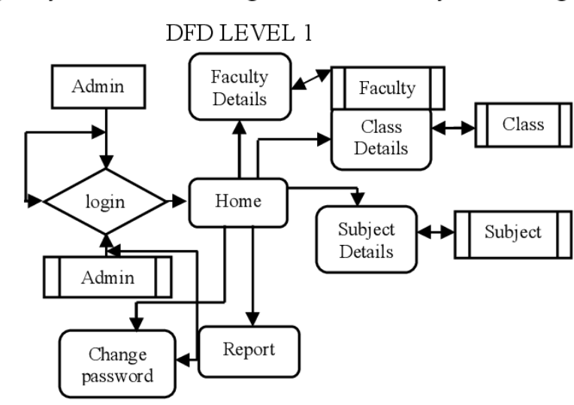

**General 2nd level Data Flow Diagram**

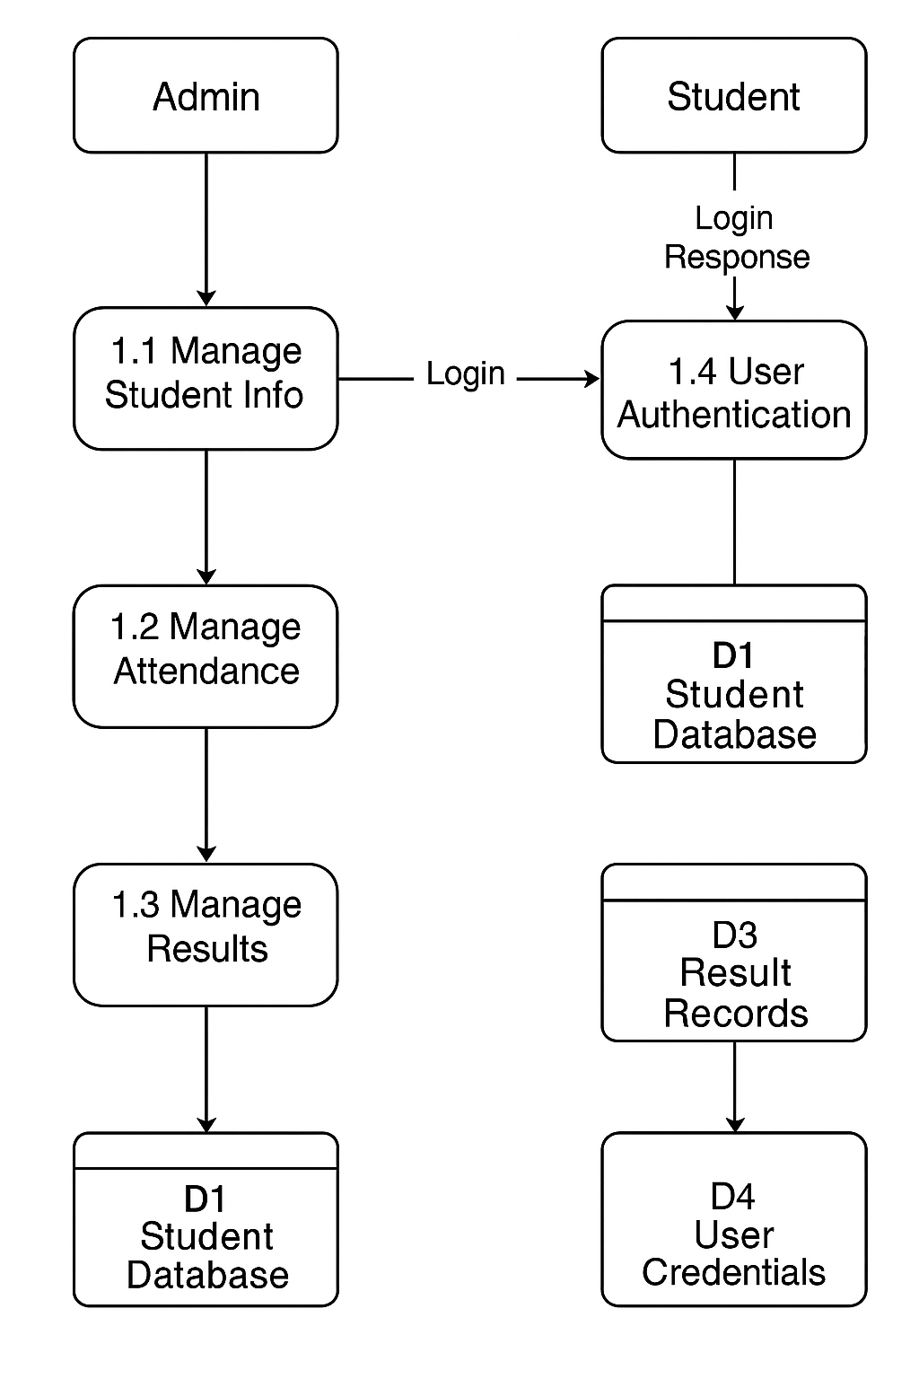

**Entity Relationship Diagram (ERD) :**

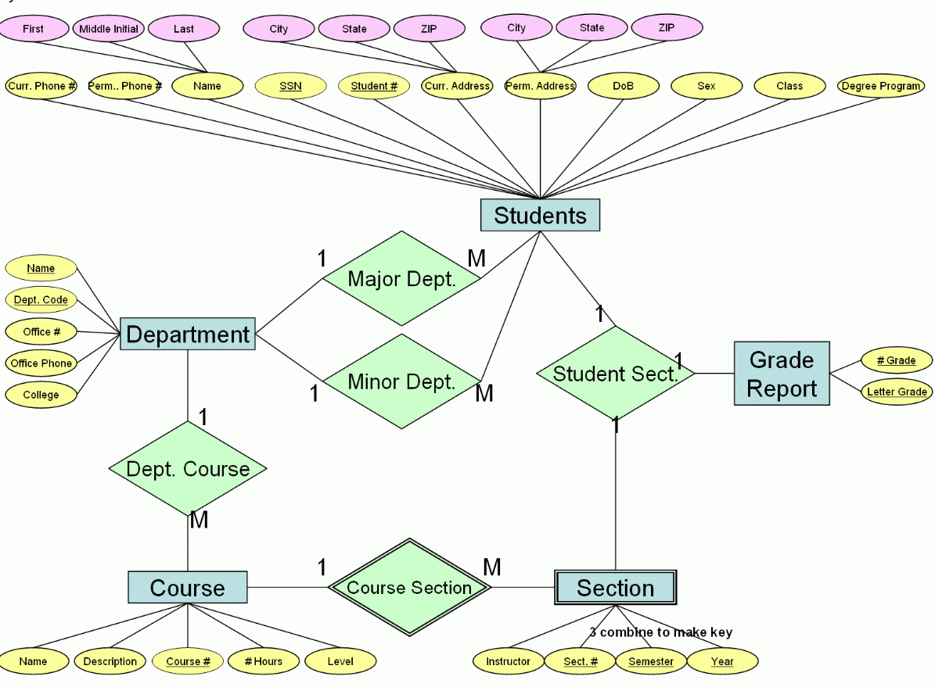

**SYSTEM DESIGN**

▪ **MODULES AND THEIR DESCRIPTION**

**The various modules used in the project are as follows:**

**MODULES AND THEIR DESCRIPTION**

**1. User Authentication Module**

* **Description**: Handles login, logout, and role-based redirection for Admin, Staff, and Students.
* **Features**:
  + Secure login using Django’s auth system
  + Custom backend for email-based login
  + Session handling and access control

**2. Admin Module**

* **Description**: Provides administrative control over users and academic data.
* **Features**:
  + Add/Edit/Delete Staff, Students, Courses, and Subjects
  + Assign subjects to staff
  + Manage student results
  + View attendance and feedback reports

**3. Staff Module**

* **Description**: Enables teaching staff to manage attendance and student performance.
* **Features**:
  + Mark and update student attendance
  + Add or edit student marks
  + View feedback submitted by students

**4. Student Module**

* **Description**: Allows students to access academic records and communicate feedback.
* **Features**:
  + View attendance records
  + View academic results
  + Submit feedback on teaching/staff

**5. Attendance Management Module**

* **Description**: Tracks and stores student attendance data.
* **Features**:
  + Class-wise attendance marking
  + Daily and monthly tracking
  + Attendance reporting for admin and staff

**6. Result Management Module**

* **Description**: Handles entry, storage, and display of student academic results.
* **Features**:
  + Add/edit subject-wise marks
  + Auto-calculated grade display
  + View results (student & admin access)

**7. Feedback Management Module**

* **Description**: Collects and displays student feedback about teachers or the system.
* **Features**:
  + Feedback submission by students
  + View feedback by staff and admin
  + Feedback analytics (if implemented)

**8. Email Backend Module**

* **Description**: Handles email-based login system and system notifications (optional).
* **Features**:
* + Custom email backend for authentication
  + Password reset or account alerts (if extended)

▪ **DATA STRUCTURE OF ALL MODULES:**

# Table Name:show databases;

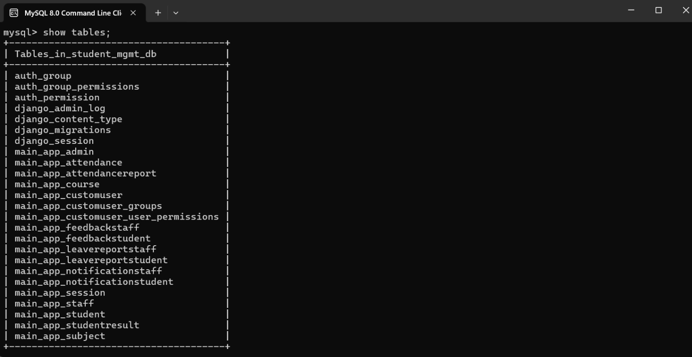

Table Name: main_app_student; 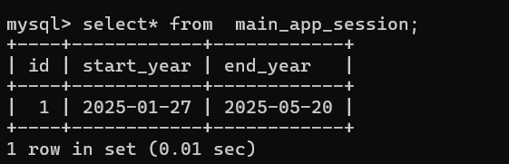

**Table Name: main_app_session;**



# Table Name: main_app_studentresult;

# 

**Table Name : main_app_subject;**

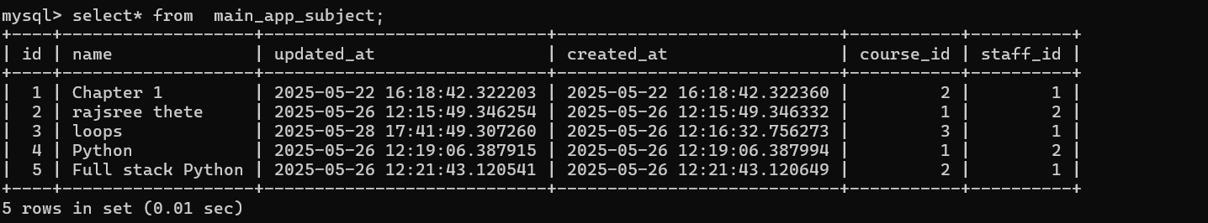

**Table Name : main_app_admin;**

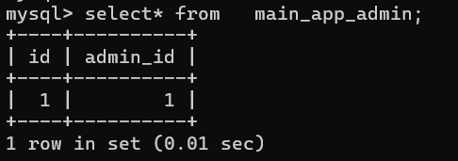

**Table Name : main_app_attendance;**

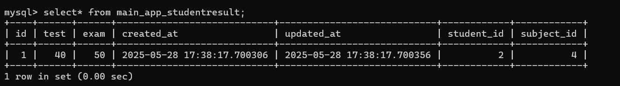

**Table Name : main_app_feedbackstaff;**

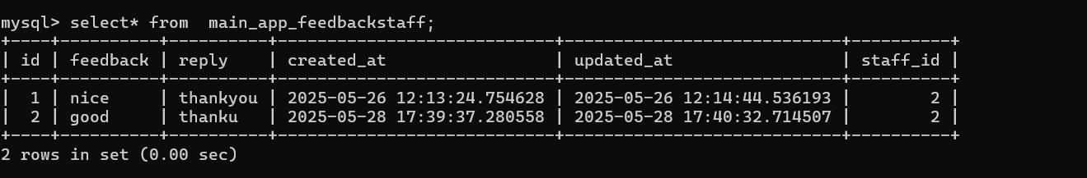

**Table Name : main_app_feedbackstudent;**

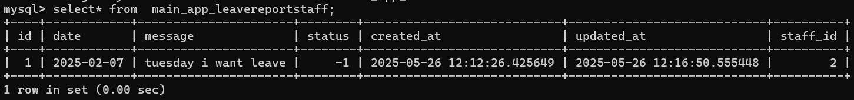

▪ **PROEDURAL DESIGN:**

**PROCESS LOGIC (FLOWCHART) OF EACH MODULE**

|  |  |  |
| --- | --- | --- |
|  | **Notations Used For FLOW CHART** | |
| **NOTATIONS** |  | **USED FOR** |
|  | Known as  **TERMINATOR** | Used for START / STOP |
|  | Known as  **DATA** | Used for ACCEPTING INPUTS  FROM USER AND also  DISPLAYING THE ERROR  MESSAGES GENERATED BY THE SYSTEM |
|  | Known as  **DECISION** | Used for DECISION MAKING |
|  | Known as **DISPLAY** | Used for OUTPUT GENERATED BY THE SYSTEM |
|  | Known as  **MAGNETIC DISK** | Used for STORING INPUTS GIVEN TO THE SYSTEM |

Flow chart for “studance attendance management”:

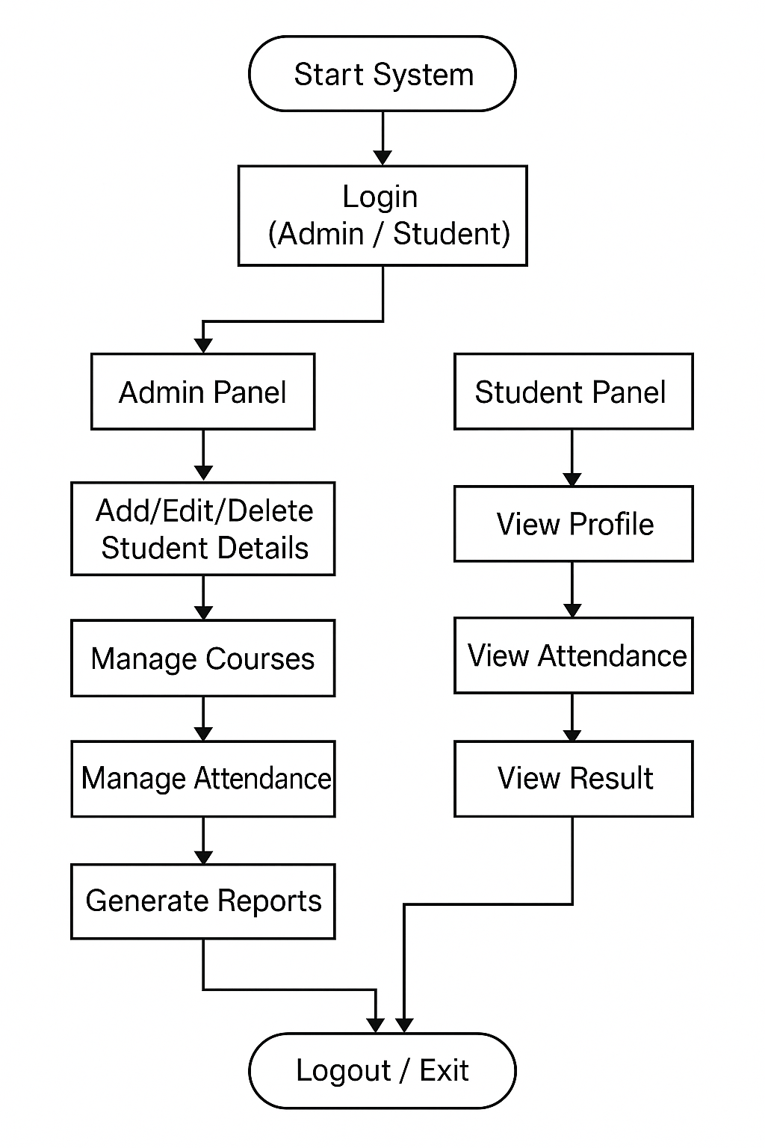

## Flow chart for “student login”

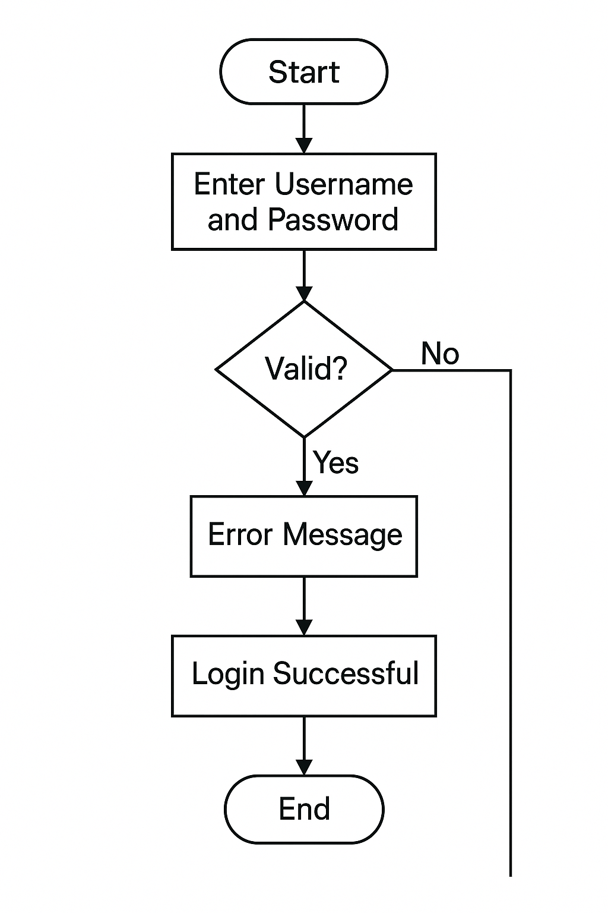

Flow chart for “Staff login”

 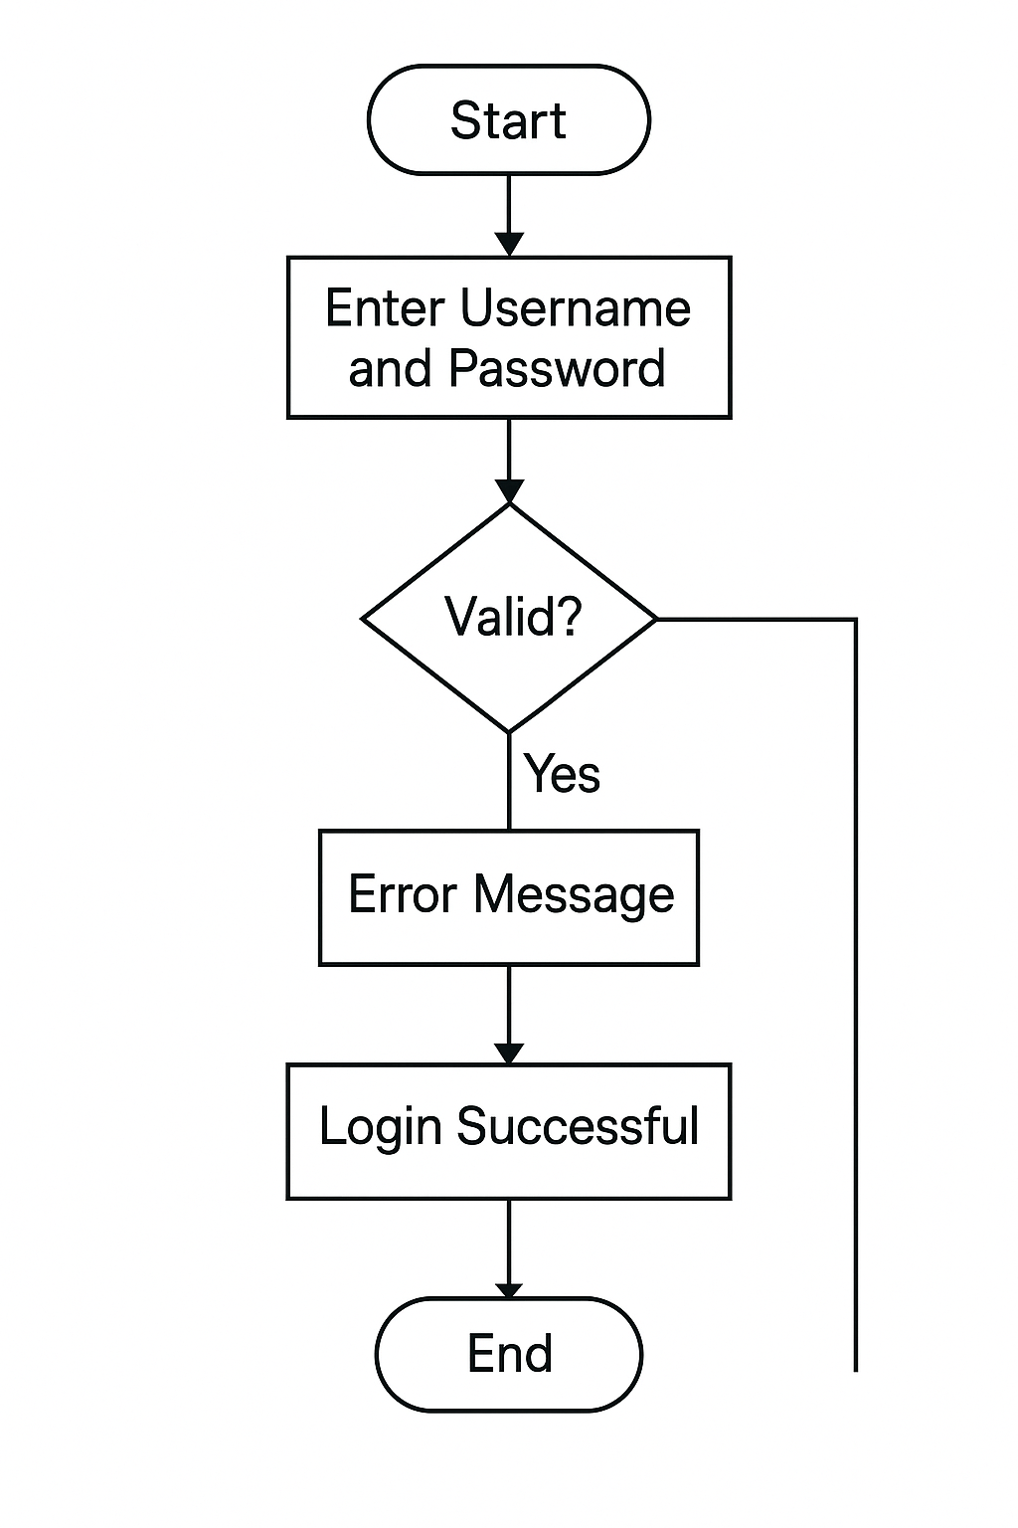

Flow chart for “Save and Display student data”

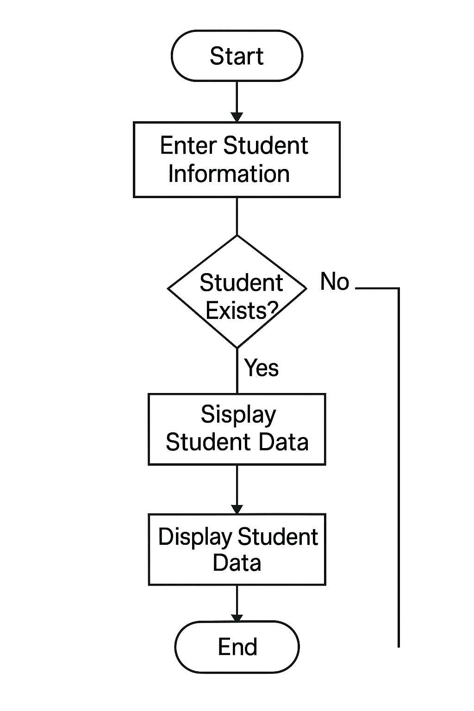

**OUTPUT SCREENS**

1. **Login Page**

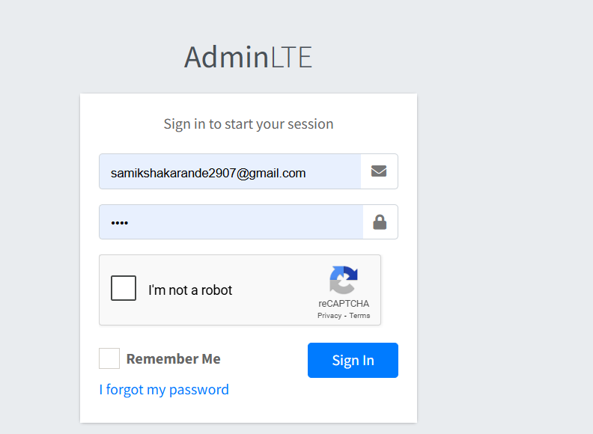

**2. Home Page**

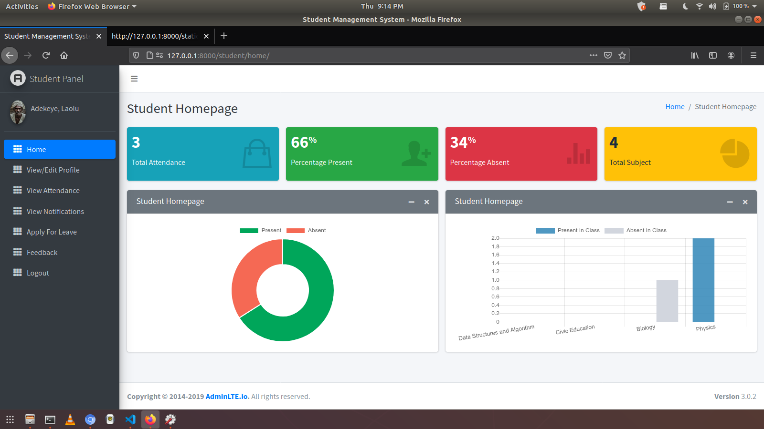

**3. About**

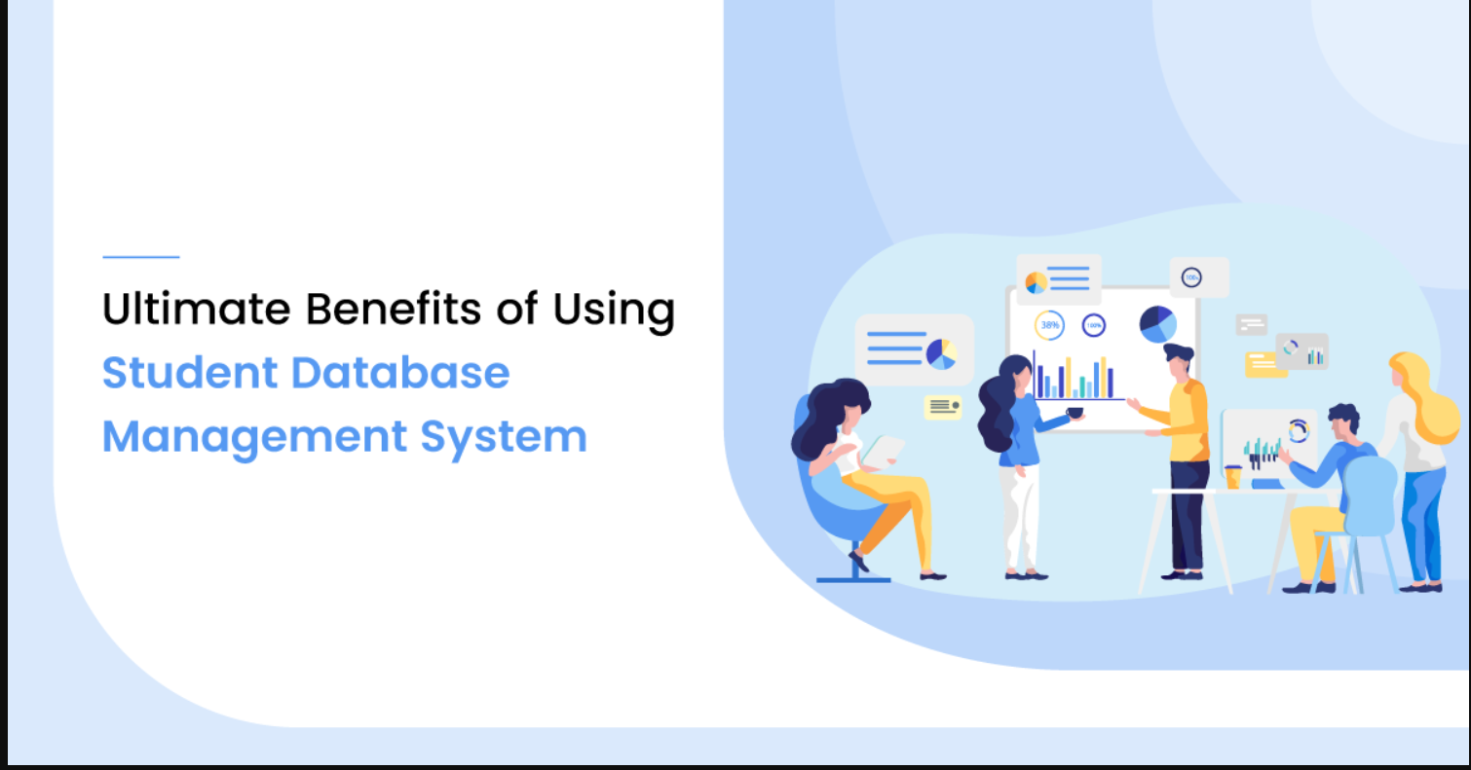

**4.Add Student Data**

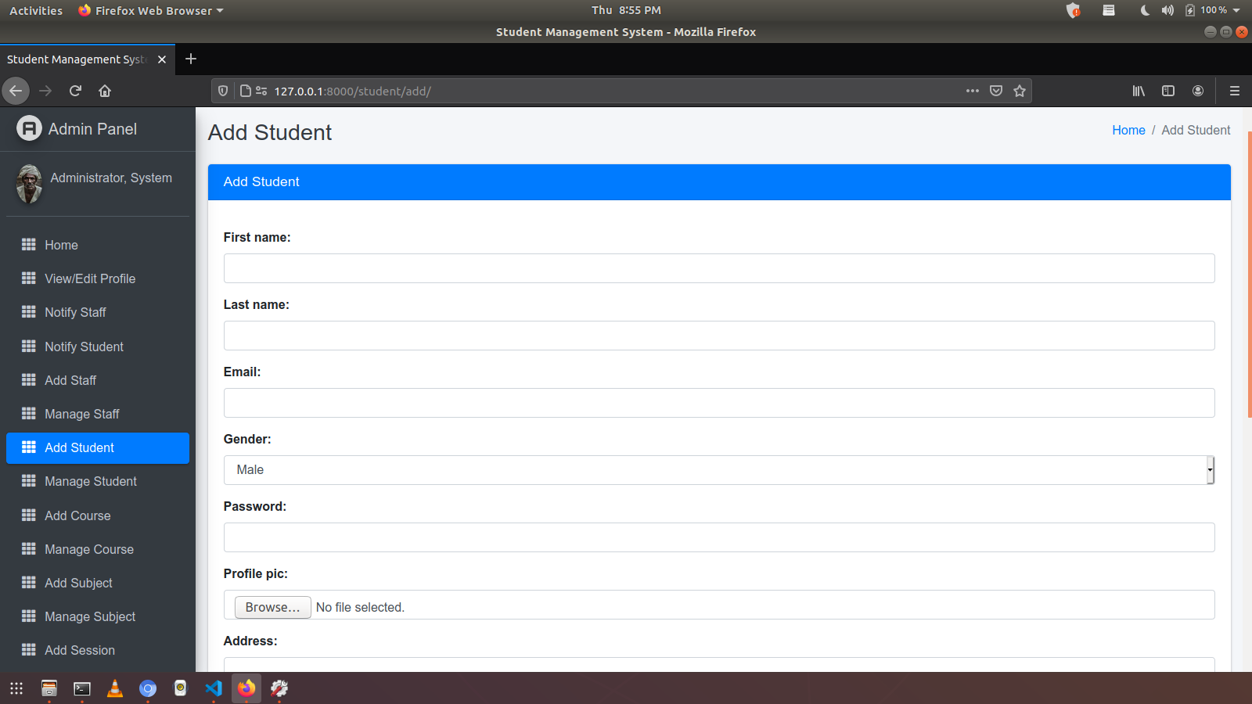

**LIST OF REPORTS THAT ARE LIKELY TO BE GENERATED**

Following types of reports can be generated from the system:

**1. Student Report**

* Full student profile
* List of all students with filters (by class, course, enrollment year)
* Attendance summary per student

**2. Attendance Report**

* Daily attendance report (by class/section)
* Monthly attendance summary
* Subject-wise attendance report
* Defaulter list (students with low attendance)

**3. Result Report**

* Individual student result card (marks per subject)
* Class-wise result analysis
* Subject performance report
* Grade distribution chart

**4. Staff Report**

* Staff profile details
* Staff attendance summary
* Assigned subjects and classes

**5. Course & Subject Report**

* List of available courses and subjects
* Enrollment statistics per course
* Subject-wise teacher allocation

**6. Feedback Report**

* Student-submitted feedback summary
* Feedback trends over time
* Department-wise or teacher-wise feedback

**7. Login Activity Report**

* User login history
* Failed login attempts
* Role-wise system access logs

**CODING**

**Sample Code:**

**1.HTML File**

**Login.html**

!DOCTYPE html>

<html>

<head>

    <meta charset="utf-8">

    <meta http-equiv="X-UA-Compatible" content="IE=edge">

    <title>Student Management System</title>

    <!-- Tell the browser to be responsive to screen width -->

    <meta name="viewport" content="width=device-width, initial-scale=1">

    <!-- Font Awesome -->

    <link rel="stylesheet" href="{% static 'plugins/fontawesome-free/css/all.min.css'%} ">

    <!-- Ionicons -->

    <link rel="stylesheet" href="https://code.ionicframework.com/ionicons/2.0.1/css/ionicons.min.css">

    <!-- Tempusdominus Bbootstrap 4 -->

    <link rel="stylesheet"

        href="{% static 'plugins/tempusdominus-bootstrap-4/css/tempusdominus-bootstrap-4.min.css'%} ">

    <!-- iCheck -->

    <link rel="stylesheet" href="{% static 'plugins/icheck-bootstrap/icheck-bootstrap.min.css'%} ">

    <!-- JQVMap -->

    <link rel="stylesheet" href="{% static 'plugins/jqvmap/jqvmap.min.css'%} ">

    <!-- Theme style -->

    <link rel="stylesheet" href="{% static 'dist/css/adminlte.min.css'%} ">

    <!-- overlayScrollbars -->

    <link rel="stylesheet" href="{% static 'plugins/overlayScrollbars/css/OverlayScrollbars.min.css'%} ">

    <!-- Daterange picker -->

    <link rel="stylesheet" href="{% static 'plugins/daterangepicker/daterangepicker.css'%} ">

    <!-- summernote -->

    <link rel="stylesheet" href="{% static 'plugins/summernote/summernote-bs4.css'%} ">

    <!-- Google Font: Source Sans Pro -->

    <link href="https://fonts.googleapis.com/css?family=Source+Sans+Pro:300,400,400i,700" rel="stylesheet">

    {% block custom_css %}

    {% endblock custom_css %}

</head>

<body class="hold-transition sidebar-mini layout-fixed">

    <div class="wrapper">

        <!-- Navbar -->

        <nav class="main-header navbar navbar-expand navbar-white navbar-light">

            <!-- Left navbar links -->

            <ul class="navbar-nav">

                <li class="nav-item">

                    <a class="nav-link" data-widget="pushmenu" href="#"><i class="fas fa-bars"></i></a>

                </li>

            </ul>

        </nav>

        <!-- /.navbar -->

        <!-- Main Sidebar Container -->

        {% include "main_app/sidebar_template.html" with user=user %}

        <div class="content-wrapper">

            <!-- Content Wrapper. Contains page content -->

            <!-- Content Header (Page header) -->

            <div class="content-header">

                <div class="container-fluid">

                    <div class="row mb-2">

                        <div class="col-sm-6">

                            <h1 class="m-0 text-dark">{% block page_title %}{% endblock page_title %}</h1>

                        </div><!-- /.col -->

                        <div class="col-sm-6">

                            <ol class="breadcrumb float-sm-right">

                                <li class="breadcrumb-item"><a href="#">Home</a></li>

                                <li class="breadcrumb-item active">{{ page_title }}</li>

                            </ol>

                        </div><!-- /.col -->

                    </div><!-- /.row -->

                </div><!-- /.container-fluid -->

            </div>

            <!-- /.content-header -->

            <!-- Main content -->

<section class="content">

    <div class="container-fluid">

        <div class="row">

            <div class="col-md-12">

            <div class="form-group">

                {% if messages %}

                {% for message in messages  %}

                {% if message.tags == 'success' %}

                <div class="alert alert-success">

                    {{message}}

                </div>

                {% else %}

                <div class="alert alert-danger">

                    {{message}}

                </div>

                {% endif %}

                {% endfor %}

                {% endif %}

            </div>

            </div></div></div></section>

            {% block content %}

            {% endblock content %}

            <!-- /.content -->

        </div>

        <!-- /.content-wrapper -->

        {% include "main_app/footer.html" %}

    </div>

    <!-- ./wrapper -->

    <!-- jQuery -->

    <script src="{% static 'plugins/jquery/jquery.min.js'%} "></script>

    <!-- jQuery UI 1.11.4 -->

    <script src="{% static 'plugins/jquery-ui/jquery-ui.min.js'%} "></script>

    <!-- Resolve conflict in jQuery UI tooltip with Bootstrap tooltip -->

    <script>

        $.widget.bridge('uibutton', $.ui.button)

    </script>

    <!-- Bootstrap 4 -->

    <script src="{% static 'plugins/bootstrap/js/bootstrap.bundle.min.js'%} "></script>

    <!-- ChartJS -->

    <script src="{% static 'plugins/chart.js/Chart.min.js'%} "></script>

    <!-- Sparkline -->

    <script src="{% static 'plugins/sparklines/sparkline.js'%} "></script>

    <!-- JQVMap -->

    <script src="{% static 'plugins/jqvmap/jquery.vmap.min.js'%} "></script>

    <script src="{% static 'plugins/jqvmap/maps/jquery.vmap.usa.js'%} "></script>

    <!-- jQuery Knob Chart -->

    <script src="{% static 'plugins/jquery-knob/jquery.knob.min.js'%} "></script>

    <!-- daterangepicker -->

    <script src="{% static 'plugins/moment/moment.min.js'%} "></script>

    <script src="{% static 'plugins/daterangepicker/daterangepicker.js'%} "></script>

    <!-- Tempusdominus Bootstrap 4 -->

    <script src="{% static 'plugins/tempusdominus-bootstrap-4/js/tempusdominus-bootstrap-4.min.js'%} "></script>

    <!-- Summernote -->

    <script src="{% static 'plugins/summernote/summernote-bs4.min.js'%} "></script>

    <!-- overlayScrollbars -->

    <script src="{% static 'plugins/overlayScrollbars/js/jquery.overlayScrollbars.min.js'%} "></script>

    <!-- AdminLTE App -->

    <script src="{% static 'dist/js/adminlte.js'%} "></script>

    <!-- AdminLTE dashboard demo (This is only for demo purposes) -->

    <script src="{% static 'dist/js/pages/dashboard.js'%} "></script>

    <!-- AdminLTE for demo purposes -->

    <script src="{% static 'dist/js/demo.js'%} "></script>

    {% block custom_js %}

    {% endblock custom_js %}

</body>

</html>

About.html

{% extends 'base.html' %}

{% load static %}

{% block title %} About Contact World {% endblock title %}

{% extends 'base.html' %}

{% load static %}

{% block title %} About Contact World {% endblock title %}

{% block content %}

<div class="container my-4">

<h4 class="text-info">Welcome to Contact World - Your Smart Contact Management Solution</h4>

</div>

<div class="row justify-content-center">

<div class="col-md-6">

<h2 class="featurette-heading text-success">

Effortless Contact Management <span class="text-muted">Made Simple</span>

</h2>

<p class="lead mt-4">

Contact World is a modern web application built with Django that helps individuals and teams organize their personal or business contacts with ease.

</p>

<p class="lead">

Store essential information like names, phone numbers, email addresses, and notes all in one place. Our platform allows you to search, update, and manage contacts securely and efficiently.

</p>

<p class="lead">

Designed for professionals, freelancers, and small businesses looking to streamline communication and keep relationships organized.

</p>

</div>

<div class="col-md-4">

<img class="featurette-image img-fluid mx-auto shadow-lg p-1 bg-secondary rounded"

alt="Contact Management"

style="width: 250px; height: 250px!important;"

src="{% static 'images/connect.jpg' %}"

data-holder-rendered="true">

<div class="my-3">

<a href="{% url 'home' %}"><button class="btn btn-outline-dark" type="button" name="button">Explore App</button></a>

</div>

</div>

</div>

{% endblock %}

**Index.html**

{% extends 'base.html' %}

{% load static %}

{% block title%}

My Contacts

{% endblock title %}

{% block content %}

<!-- Main Section -->

<div class="container">

<h3 class="heading font-weight-light">Here are your contacts</h3>

<hr />

</div>

<div class="container main-part">

{% if contacts %}

{% for contact in contacts %}

{% include 'partials/_card.html' %}

{% endfor %}

{% else %}

<p class="d-block font-weight-light my-2 heading">You have not save any contacts yet!</p>

{% endif %}

</div>

{% endblock content %}

**Logged_out.html**

{% extends 'base.html' %}

{% block title %}

Logout

{% endblock title %}

{% block content %}

<div class="container">

<h2 class="heading font-weight-light text-center">Login</h2>

<hr>

</div>

<div class="container w-25 card p-4 mt-4 bg-dark text-light">

<p class="font-weight-light">

You have been logged out. <br>

You can log in again &nbsp;&nbsp;&nbsp;

<a href="{% url 'login' %}" class="text-info">

<button type="button" class="btn btn-outline-light">Using this link</button>

</a>

</p>

</div>

{% endblock content %}

**Django Files:**

**admin.py**

from django.contrib import admin

from django.contrib.auth.admin import UserAdmin

from .models import *

# Register your models here.

class UserModel(UserAdmin):

    ordering = ('email',)

admin.site.register(CustomUser, UserModel)

admin.site.register(Staff)

admin.site.register(Student)

admin.site.register(Course)

admin.site.register(Subject)

admin.site.register(Session)

**Models.py**

from django.contrib.auth.hashers import make_password

from django.contrib.auth.models import UserManager

from django.dispatch import receiver

from django.db.models.signals import post_save

from django.db import models

from django.contrib.auth.models import AbstractUser

class CustomUserManager(UserManager):

    def _create_user(self, email, password, **extra_fields):

        email = self.normalize_email(email)

        user = CustomUser(email=email, **extra_fields)

        user.password = make_password(password)

        user.save(using=self._db)

        return user

    def create_user(self, email, password=None, **extra_fields):

        extra_fields.setdefault("is_staff", False)

        extra_fields.setdefault("is_superuser", False)

        return self._create_user(email, password, **extra_fields)

    def create_superuser(self, email, password=None, **extra_fields):

        extra_fields.setdefault("is_staff", True)

        extra_fields.setdefault("is_superuser", True)

        assert extra_fields["is_staff"]

        assert extra_fields["is_superuser"]

        return self._create_user(email, password, **extra_fields**)**

class Session(models.Model):

    start_year = models.DateField()

    end_year = models.DateField()

    def __str__(self):

        return "From " + str(self.start_year) + " to " + str(self.end_year)

class CustomUser(AbstractUser):

    USER_TYPE = ((1, "HOD"), (2, "Staff"), (3, "Student"))

    GENDER = [("M", "Male"), ("F", "Female")]

    username = None  # Removed username, using email instead

    email = models.EmailField(unique=True)

    user_type = models.CharField(default=1, choices=USER_TYPE, max_length=1)

    gender = models.CharField(max_length=1, choices=GENDER)

    profile_pic = models.ImageField()

    address = models.TextField()

    fcm_token = models.TextField(default="")  # For firebase notifications

    created_at = models.DateTimeField(auto_now_add=True)

    updated_at = models.DateTimeField(auto_now=True)

    USERNAME_FIELD = "email"

    REQUIRED_FIELDS = []

    objects = CustomUserManager()

    def __str__(self):

        return self.last_name + ", " + self.first_name

class Admin(models.Model):

    admin = models.OneToOneField(CustomUser, on_delete=models.CASCADE)

class Course(models.Model):

    name = models.CharField(max_length=120)

    created_at = models.DateTimeField(auto_now_add=True)

    updated_at = models.DateTimeField(auto_now=True)

    def __str__(self):

        return self.name

class Student(models.Model):

    admin = models.OneToOneField(CustomUser, on_delete=models.CASCADE)

    course = models.ForeignKey(Course, on_delete=models.DO_NOTHING, null=True, blank=False)

    session = models.ForeignKey(Session, on_delete=models.DO_NOTHING, null=True)

    def __str__(self):

        return self.admin.last_name + ", " + self.admin.first_name

class Staff(models.Model):

    course = models.ForeignKey(Course, on_delete=models.DO_NOTHING, null=True, blank=False)

    admin = models.OneToOneField(CustomUser, on_delete=models.CASCADE)

    def __str__(self):

        return self.admin.last_name + " " + self.admin.first_name

class Subject(models.Model):

    name = models.CharField(max_length=120)

    staff = models.ForeignKey(Staff,on_delete=models.CASCADE,)

    course = models.ForeignKey(Course, on_delete=models.CASCADE)

    updated_at = models.DateTimeField(auto_now=True)

    created_at = models.DateTimeField(auto_now_add=True)

    def __str__(self):

        return self.name

class Attendance(models.Model):

    session = models.ForeignKey(Session, on_delete=models.DO_NOTHING)

    subject = models.ForeignKey(Subject, on_delete=models.DO_NOTHING)

    date = models.DateField()

    created_at = models.DateTimeField(auto_now_add=True)

    updated_at = models.DateTimeField(auto_now=True)

class AttendanceReport(models.Model):

    student = models.ForeignKey(Student, on_delete=models.DO_NOTHING)

    attendance = models.ForeignKey(Attendance, on_delete=models.CASCADE)

    status = models.BooleanField(default=False)

    created_at = models.DateTimeField(auto_now_add=True)

    updated_at = models.DateTimeField(auto_now=True)

class LeaveReportStudent(models.Model):

    student = models.ForeignKey(Student, on_delete=models.CASCADE)

    date = models.CharField(max_length=60)

    message = models.TextField()

    status = models.SmallIntegerField(default=0)

    created_at = models.DateTimeField(auto_now_add=True)

    updated_at = models.DateTimeField(auto_now=True)

class LeaveReportStaff(models.Model):

    staff = models.ForeignKey(Staff, on_delete=models.CASCADE)

    date = models.CharField(max_length=60)

    message = models.TextField()

    status = models.SmallIntegerField(default=0)

    created_at = models.DateTimeField(auto_now_add=True)

    updated_at = models.DateTimeField(auto_now=True)

class FeedbackStudent(models.Model):

    student = models.ForeignKey(Student, on_delete=models.CASCADE)

    feedback = models.TextField()

    reply = models.TextField()

    created_at = models.DateTimeField(auto_now_add=True)

    updated_at = models.DateTimeField(auto_now=True)

class FeedbackStaff(models.Model):

    staff = models.ForeignKey(Staff, on_delete=models.CASCADE)

    feedback = models.TextField()

    reply = models.TextField()

    created_at = models.DateTimeField(auto_now_add=True)

    updated_at = models.DateTimeField(auto_now=True)

class NotificationStaff(models.Model):

    staff = models.ForeignKey(Staff, on_delete=models.CASCADE)

    message = models.TextField()

    created_at = models.DateTimeField(auto_now_add=True)

    updated_at = models.DateTimeField(auto_now=True)

class NotificationStudent(models.Model):

    student = models.ForeignKey(Student, on_delete=models.CASCADE)

    message = models.TextField()

    created_at = models.DateTimeField(auto_now_add=True)

    updated_at = models.DateTimeField(auto_now=True)

class StudentResult(models.Model):

    student = models.ForeignKey(Student, on_delete=models.CASCADE)

    subject = models.ForeignKey(Subject, on_delete=models.CASCADE)

    test = models.FloatField(default=0)

    exam = models.FloatField(default=0)

    created_at = models.DateTimeField(auto_now_add=True)

    updated_at = models.DateTimeField(auto_now=True)

@receiver(post_save, sender=CustomUser)

def create_user_profile(sender, instance, created, **kwargs):

    if created:

        if instance.user_type == 1:

            Admin.objects.create(admin=instance)

        if instance.user_type == 2:

            Staff.objects.create(admin=instance)

        if instance.user_type == 3:

            Student.objects.create(admin=instance)

@receiver(post_save, sender=CustomUser)

def save_user_profile(sender, instance, **kwargs):

    if instance.user_type == 1:

        instance.admin.save()

    if instance.user_type == 2:

        instance.staff.save()

    if instance.user_type == 3:

        instance.student.save()

**urls.py**

from django.contrib import admin

from django.urls import path, include

from django.conf.urls.static import static

from . import settings

urlpatterns = [

    path("", include('main_app.urls')),

    path("accounts/", include("django.contrib.auth.urls")),

    path('admin/', admin.site.urls),

] + static(settings.MEDIA_URL, document_root=settings.MEDIA_ROOT) + static(settings.STATIC_URL, document_root=settings.STATIC_ROOT)

**Views.py**

import json

import requests

from django.contrib import messages

from django.contrib.auth import authenticate, login, logout

from django.http import HttpResponse, JsonResponse

from django.shortcuts import get_object_or_404, redirect, render, reverse

from django.views.decorators.csrf import csrf_exempt

from .EmailBackend import EmailBackend

from .models import Attendance, Session, Subject

# Create your views here.

def login_page(request):

    if request.user.is_authenticated:

        if request.user.user_type == '1':

            return redirect(reverse("admin_home"))

        elif request.user.user_type == '2':

            return redirect(reverse("staff_home"))

        else:

            return redirect(reverse("student_home"))

    return render(request, 'main_app/login.html')

def doLogin(request, **kwargs):

    if request.method != 'POST':

        return HttpResponse("<h4>Denied</h4>")

    else:

        #Google recaptcha

        captcha_token = request.POST.get('g-recaptcha-response')

        captcha_url = "https://www.google.com/recaptcha/api/siteverify"

        captcha_key = "6LfswtgZAAAAABX9gbLqe-d97qE2g1JP8oUYritJ"

        data = {

            'secret': captcha_key,

            'response': captcha_token

        }

        # Make request

        try:

            captcha_server = requests.post(url=captcha_url, data=data)

            response = json.loads(captcha_server.text)

            if response['success'] == False:

                messages.error(request, 'Invalid Captcha. Try Again')

                return redirect('/')

        except:

            messages.error(request, 'Captcha could not be verified. Try Again')

            return redirect('/')

        #Authenticate

        user = EmailBackend.authenticate(request, username=request.POST.get('email'), password=request.POST.get('password'))

        if user != None:

            login(request, user)

            if user.user_type == '1':

                return redirect(reverse("admin_home"))

            elif user.user_type == '2':

                return redirect(reverse("staff_home"))

            else:

                return redirect(reverse("student_home"))

        else:

            messages.error(request, "Invalid details")

            return redirect("/")

def logout_user(request):

    if request.user != None:

        logout(request)

    return redirect("/")

@csrf_exempt

def get_attendance(request):

    subject_id = request.POST.get('subject')

    session_id = request.POST.get('session')

    try:

        subject = get_object_or_404(Subject, id=subject_id)

        session = get_object_or_404(Session, id=session_id)

        attendance = Attendance.objects.filter(subject=subject, session=session)

        attendance_list = []

        for attd in attendance:

            data = {

                    "id": attd.id,

                    "attendance_date": str(attd.date),

                    "session": attd.session.id

                    }

            attendance_list.append(data)

        return JsonResponse(json.dumps(attendance_list), safe=False)

    except Exception as e:

        return None

**Manage.py**

import os

import sys

def main():

    """Run administrative tasks."""

    os.environ.setdefault('DJANGO_SETTINGS_MODULE', 'student_management_system.settings')

    try:

        from django.core.management import execute_from_command_line

    except ImportError as exc:

        raise ImportError(

            "Couldn't import Django. Are you sure it's installed and "

            "available on your PYTHONPATH environment variable? Did you "

            "forget to activate a virtual environment?"

        ) from exc

    execute_from_command_line(sys.argv)

if __name__ == '__main__':

    main()

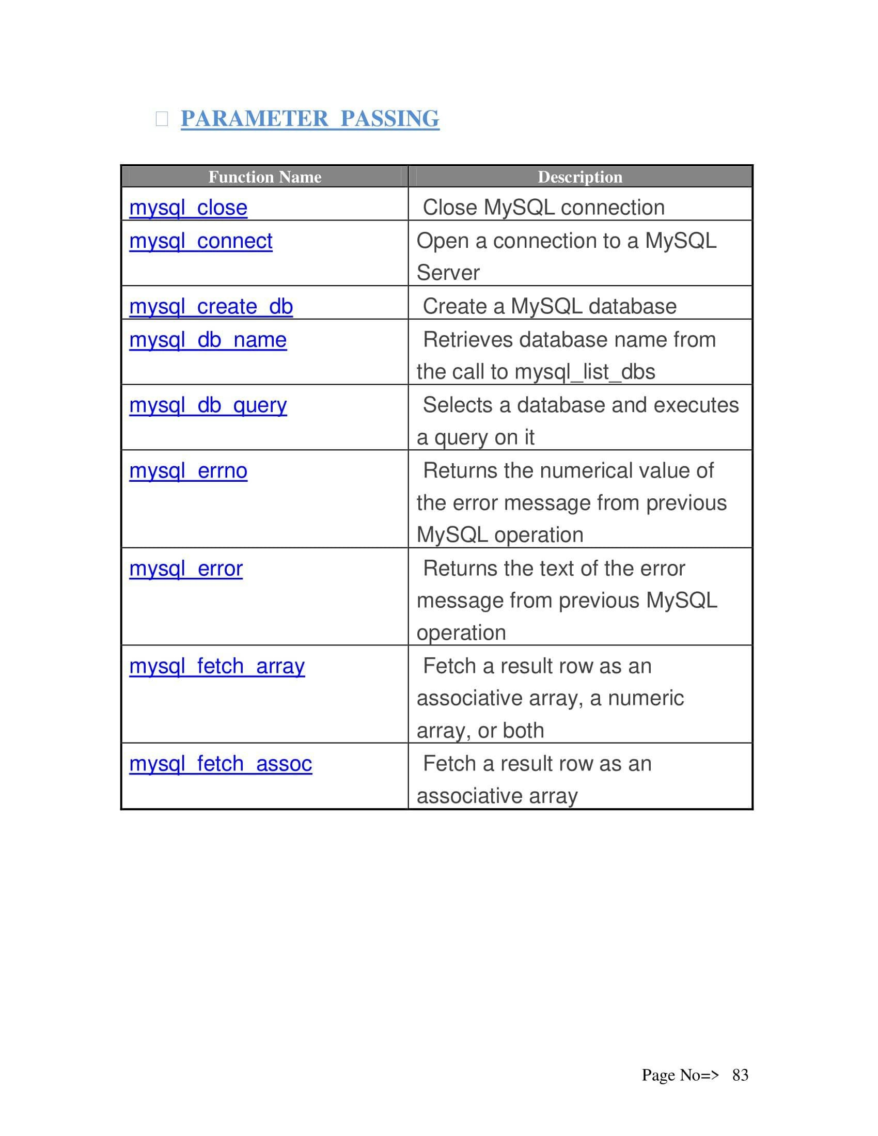

**Testing**

### ****Testing Strategy Overview:****

**Definition of Testing:**

* Testing is a process to provide stakeholders with information about the quality of a software product or service.
* It offers an independent view of the software to help stakeholders understand risks during implementation.
* It involves executing a program/application to detect software bugs.

**Purpose of Software Testing:**

* To validate and verify that a software program:
  1. Meets business and technical requirements.
  2. Works as expected.
  3. Can be implemented with consistent results.

**When Testing is Done:**

* Testing can be done at any point in the development process.
* Typically, most testing is done after requirements are defined and coding is complete.

**Testing in Development Models:**

* **Traditional models:** Testing happens after the development phase.
* **Agile and modern models:** Emphasize **test-driven development** where developers do more testing during coding before formal testers are involved.

**Limitations of Testing:**

* Testing can’t find every defect.
* It acts as a **criticism or comparison**, checking if the software behaves correctly based on defined expectations (called oracles).

### Testing methods

Software testing methods are traditionally divided into and white- and black-box testing. These two approaches are used to describe the point of view that a test engineer takes when designing test cases.

### ****Unit testing****

**Unit testing** refers to tests that verify the functionality of a specific section of code, usually at the function level. In an object-oriented environment, this is usually at the class level, and the minimal unit tests include the constructors and destructors.

In unit testing, the smallest unit of the software, i.e. modules, is tested. This test focuses on the internal process logic and data structure within the boundaries of a component.

These types of tests are usually written by developers as they work on code  
(white-box style), to ensure that the specific function is working as expected. One function might have multiple tests, to catch corner cases or other branches in the code. Unit testing alone cannot verify the functionality of a piece of software, but rather is used to assure that the building blocks the software uses work independently of each other.

Unit testing is also called **component testing**.

**UNIT TESTING**

**Test Case # 1.**

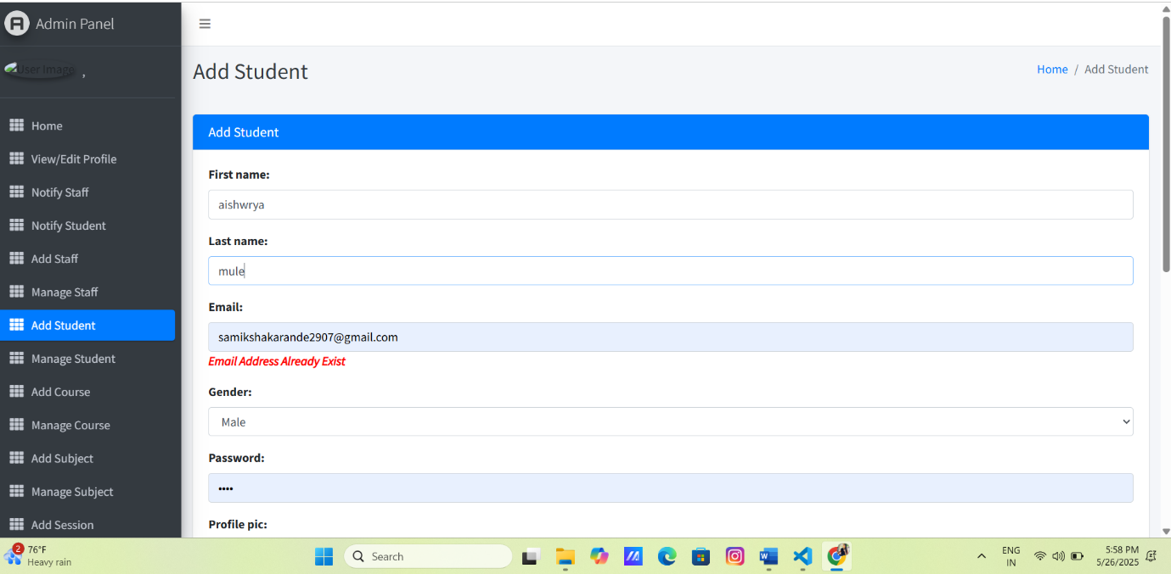

**Test Case#2**

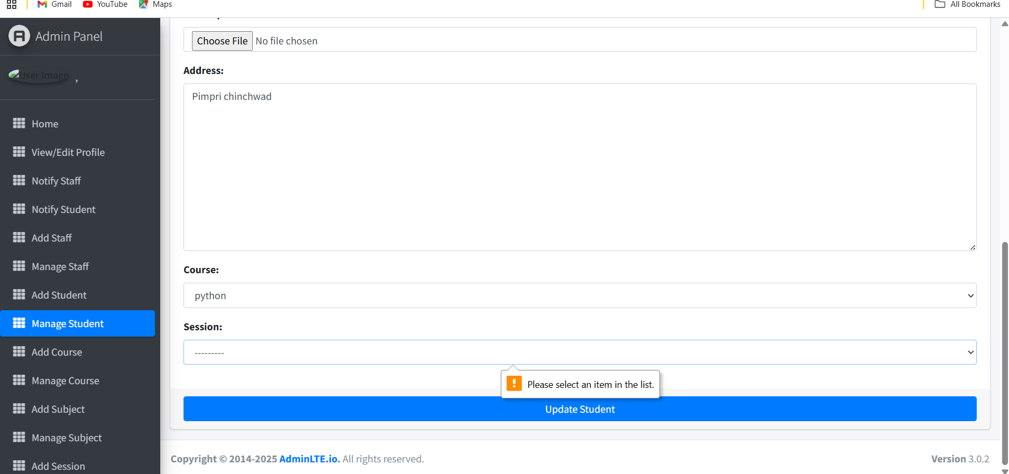

**Test Case #3**

Email Address Field Validation

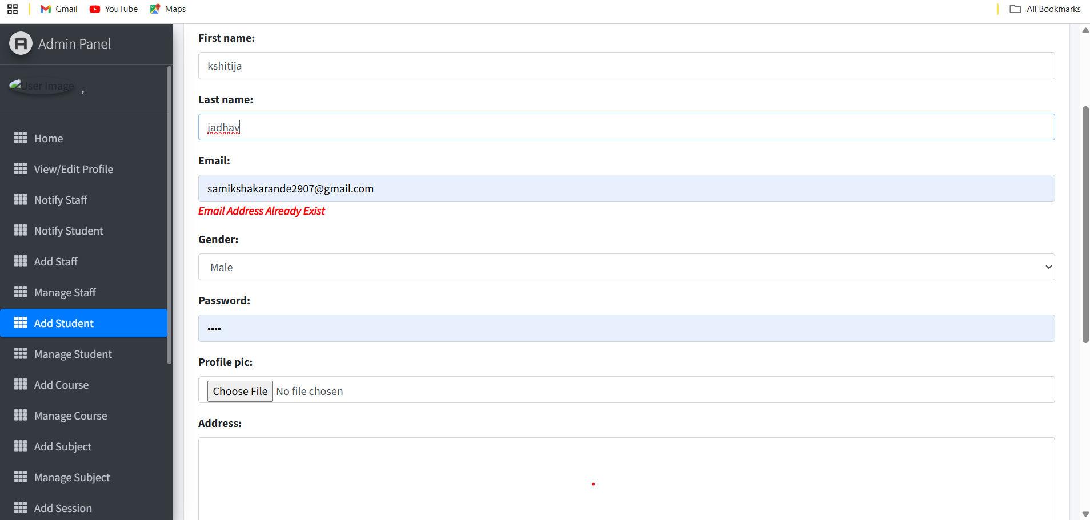

**SYSTEM SECURITY**

This software itself being a security project provides some of the best software security measures. In this website a user cannot login and use the features and facilities provided by the website without creating user account. Instead of that every time the user wants to login he has to give his user name and password which adds to the security of the project. Moreover, all the data that are saved using this software are encrypted i.e. no unauthorized user cannot access it.  
**Security Issues of ISO 74982:**  
➢ **Authentication:**  
 It is any process by which a system verifies the identity of a user who wishes to access the resource stored in system.

➢ **Access Control:**  
 Access control is ability to permit or deny the use of a particular resource by particular entity.

➢ **Confidentiality:**  
 The website we will develop will achieve data security through Encryption/Decryption concept.

➢ **Data Integrity:**  
 With the help of this website we can handle data accessing, webpage bugs can be deleted and improved later on.

➢ **Non-repudiation:**  
 ❖ This website will be user specific i.e. only some user can access specific commands buttons.  
 ❖ The website will use security policy which specifies who is authorized to do the task.

**Data Integrity, Non-repudiation**

The security is the most important factor of any project. Here the main concern is that the project is based on Online that means the security part should be very high in order to protect the system. The security system maintains the data integrity of the whole system. The security system is maintained by allowing the user to enter a login id and password to login to the system.

***1. Site Administrator:***Site Administrator is the actually Super user of this site that means s/he can only access the all features provided by the site. Administrator also can manipulate the database. S/he also can view the all reports generated by the System.

### INTERFACE SECURITY

The site Administrator is only the super user of this website. S/he can only access all the features of the site and also can view all system generated reports. As a other user can just only view the site as a normal site viewer.  
Can only get their own profile.  
Therefore, for Site Administrator there is Login Profile procedure. Admin user can access the site by providing valid login profile through the following login Page:

Login Page

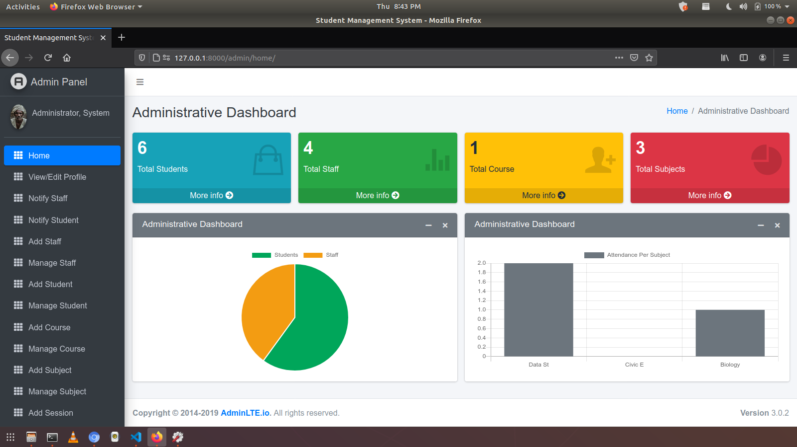

**DATABASE SECURITY**

Database is the storage device. That means the data is getting stored in the database server. Thus it is very important to secure the data residing in the database. Thus every database server provides a login procedure. This technique is similar to application level security. The entity which is willing to use the database has to supply in a login ID and password to access and manipulate the data in the database. Every database server provides a default login ID and password to access the data. Apart from this the database administrator can also create other database user.

In this project the default login ID and password has been used. Since the database server used in this project is **MYSQL** thus the default login ID and password is:  
**Login id:** samikshakarande2907@gmail.com  
**password:** 1234  
**Hostname:** localhost

**Database Connectivity**

import mysql.connector

conn = mysql.connector.connect(

host="localhost",

user="root",

password="", # Use your password if not blank

database="contact_db" # Replace with your actual database name

)

# Create a cursor object to execute SQL commands

cursor = conn.cursor()

# Check connection

if conn.is_connected():

print("Connected to MySQL database successfully.")

else:

print("Failed to connect.")

**FUTURE SCOPE OF THE PROJECT**

**Future Scope**

The Student Management System has great potential for future enhancement. As educational institutions continue to evolve, so do their technological needs. The system can be expanded and improved in several key areas:

**1. Integration with Other Educational Systems**

* Connect with Learning Management Systems (LMS) like Moodle, Google Classroom, or Blackboard.
* Enable real-time data sharing between the student portal and administrative platforms.

**2. Mobile Application Support**

* Develop Android and iOS apps for students, teachers, and administrators.
* Features like push notifications, attendance updates, and exam reminders can improve engagement.

**3. Advanced Analytics and Reporting**

* Implement data analytics to track student performance trends.
* Provide predictive insights (e.g., at-risk students, top performers) using AI or machine learning.

**4. Biometric or RFID-Based Attendance**

* Use fingerprint or facial recognition systems for secure and accurate attendance tracking.
* RFID cards can help automate class check-ins and library access.

**5. Cloud Deployment**

* Shift to cloud-based architecture for better scalability, accessibility, and backup solutions.
* Allow students and staff to access the system from anywhere with an internet connection.

**6. Chatbot Integration**

* Implement AI-powered chatbots to help answer common student queries.
* Provide 24/7 support for issues related to enrollment, class schedules, etc.

**7. Parent Portal**

* Add features that allow parents to monitor attendance, grades, and announcements.
* Improve communication between parents and educational institutions.

**8. Multi-language Support**

* Include multiple language options to cater to students from diverse backgrounds.
* Improve accessibility for international or rural users**.**

**9. Fee Payment Gateway Integration**

* Enable online fee payments through credit/debit cards, UPI, or net banking.
* Automate fee receipts and payment reminders.

**Conclusion**

**Conclusion for Student Management System**:

The Student Management System is a powerful tool designed to streamline the administration and handling of student-related data. It enables efficient management of student information, including registration, attendance, grades, and personal details. By automating manual tasks, the system reduces errors, saves time, and improves data accuracy and accessibility for staff and students alike.

This system not only enhances communication between students and faculty but also contributes to better academic monitoring and decision-making. Overall, it provides a scalable, secure, and user-friendly solution that supports modern educational institutions in delivering quality education through better data management.

**BIBLIOGRAPHY**

Henceforth, **bibliography** for a **Student Management System** project. It includes references to books, research papers, websites, and software tools typically used in the development and analysis of such systems. You can adjust the formatting depending on the citation style you are required to use (APA, MLA, IEEE, etc.).

1. **"Python Web Development with Django"  
   *By Jeff Forcier, Paul Bissex, Wesley J. Chun***
   * **Covers full-stack development using Django and Python.**
2. **"Python Web Development with Django"**  
   By Jeff Forcier, Paul Bissex, Wesley J. Chun
   * Covers full-stack development using Django and Python.

**3."Systems Analysis and Design"  
 *By Shelly Cashman Series*  
 *Focuses on planning, analysis, and design for systems like this project.***

1. **"Modern Systems Analysis and Design"**  
   *By Jeffrey A. Hoffer, Joey F. George, Joseph S. Valacich*
   * Focus on structured and object-oriented analysis with diagrams like DFDs.

**Websites:**

* <http://studentportal.university.edu>
* <http://studentportal.university.edu>
* <https://www.geeksforgeeks.org/student-management-system-using-django/>
* <https://www.youtube.com/watch?v=9s6eV2w2yKw>

<https://dev.mysql.com/doc/>